**WORKFLOW FOR THE PROCESS:**

**1)Downloading the data files and then uploading them to google colab. Then cleaning of data and data visualization was carried out(2-3 days)**

**2)Deciding which kind of architecture to work with. (1 day)**

**3)Planning the architecture and deciding the input shape of the sound files. (1 day)**

**4)Writing the code for training the dataset and checking on validation data to determine the best possible arrangement of convolutional layers. (2 days)**

**5)Finally testing on the test dataset and making required submissions. (1 day)**

**6)I was planning to increase the efficiency by using resnet and tried to implement confusion matrices for better results.**

**I was thinking about more fine-tuning the hyperparameters so that I could get better results.**

**7)I was planning to use this model to construct sentences when a user is speaking, that is, I would give a user speech and my algorithm would recognize the speech.**

**I built a basic layout and wrote some code but faced repeated errors, but given time I would work more on it and fix it.**

**8)I have read several kaggle notebooks and liked the ideas used by many of them. I have tried to replicate a few of them for my purpose.**

**9)I have read several medium articles on speech recognition which gave me insights on what king of CNN architecture might help.**

**10)Given, below is my work with various convolutional layer architecture. It layouts my motivation for selecting a particular architecture. I tried several combinations and compared the efficiency across several models and finally decided to continue with one.**

(Usage of confusion matrices would have been better. I mentioned it before as well.)

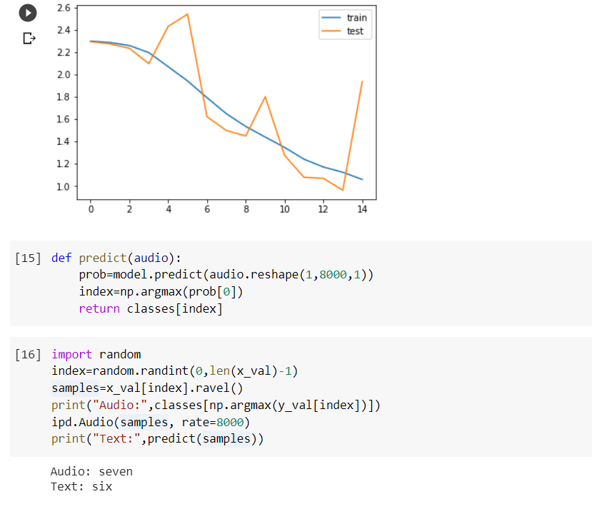

**1)**Here, I have used 4 convolutional layers and 2 dense layers. This was a purely experimental setup. I started with this and further made modifications in the layers to get various results. Based on the accuracy curves, I further made changes to get better efficiencies. I have shown the various graphs below:

**2)**In the next figure, I have used six convolutional layers and 3 dense layers.

I have added the structure of convolutional and dense layers below for reference,

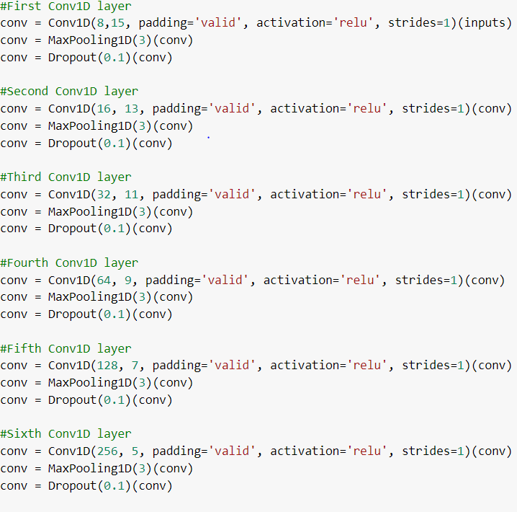

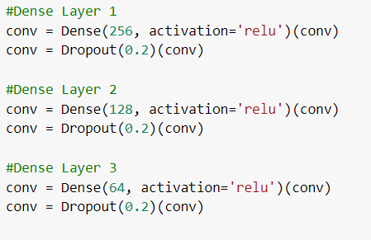

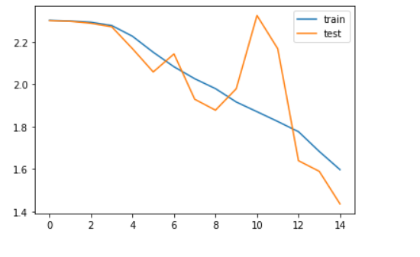

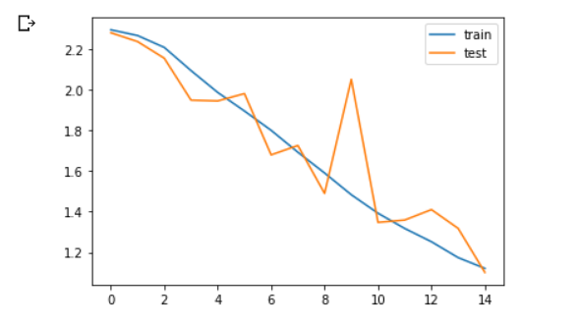

**3)**Here I used 2 convolutional layers with 3 dense layers.

**4)**So far I have been changing the number of convolutional and dense layers and had kept the number of iterations fixed to 15.

Now using the last combination I will run on 100 iterations, till I find the best model for my purpose.

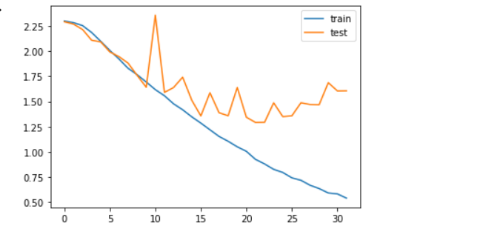

**5)**Iterations stopped at iteration number 32 giving the best accuracies. From the plot, it is visible that validation, as well as test error, has also reduced a lot.

Now I have saved the model and will use it to predict the test data.

Further, I have tested the given dataset on this model and achieved a score of 0.8019